# Smart Jacket for Health Monitoring of Climbers Using LoRa Technology

# D. Supriya1, S. Vineel Reddy2, M. Sai Prakash3, P. Pavan Raj4

1Assistant Professor, Department of Computer Science & Engineering- Cybersecurity & IoT, Malla Reddy University, Hyderabad, Telangana, India. [thanduri_suneetha@mallareddyuniversity.ac.in1](mailto:thanduri_suneetha@mallareddyuniversity.ac.in1)

2,3,4Students, Department of Computer Science & Engineering- Internet of Things, Malla Reddy University, Hyderabad, Telangana, India. [**2111cs050051@mallareddyuniversity.ac.in2,**](mailto:2111cs050051@mallareddyuniversity.ac.in2)[**2111cs050037@mallareddyuniversity.ac.in**](mailto:2111cs050037@mallareddyuniversity.ac.in)**3,** [**2111cs050035@mallareddyuniversity.ac.in4**](mailto:2111cs050035@mallareddyuniversity.ac.in4)

**ABSTRACT –** Due to the harsh climatic conditions they frequently encounter, mountain climbers need constant health monitoring and real-time communication to stay safe. Real-time tracking and long-range communication are absent from traditional health monitoring equipment in remote locations. This study addresses these issues by introducing a Smart Jacket for Climbers' Health Monitoring, which integrates LoRa (Long Range) communication technology for effective and low-power data transfer in distant areas. Processing information from several environmental and physiological sensors, the system is built around the Arduino and Arduino Mega 2560. The climber's vitals are tracked by a heartbeat sensor, while the DS18B20 and DHT11 sensors detect humidity, body temperature, and ambient temperature. Long-range wireless data transmission to a distant monitoring station is made possible by the LoRa module, while the GPS module tracks the climber's location.

In the event of an emergency, the GSM module offers backup communication by sending SMS alerts. The user receives real-time feedback from LCD screens and a buzzer. Because of its lightweight, power-efficient, and incredibly dependable construction, the smart jacket guarantees constant health monitoring and communication even in challenging conditions. This system improves climbers' safety, health tracking, and remote connectivity by utilising LoRa technology, real-time monitoring, and emergency warning. The Smart Jacket for Tracking Climbers' Health LoRa is a cutting-edge wearable Internet of Things solution made to protect climbers in isolated and harsh settings.

* **Key words - Microcontroller Arduino Mega 2560, LoRa Module RA-01, GSM Module SIM Com A7672S, GPS Module NEO-6M, Pulse Sensor, Temperature Sensor (DS18B20) Digital, DHT11 Sensor, Buzzer, LCD Display, Power Supply 5V.I. INTRODUCTION**

Adventurers who engage in physically taxing sports like mountaineering and rock climbing are subjected to harsh environmental circumstances like low oxygen levels, frigid temperatures, and high altitudes. Climbers frequently run the risk of developing severe health conditions such hypoxia, hypothermia, dehydration, and exhaustion, which, if not identified in time, can become fatal.   
This project intends to create a smart jacket utilising LoRa (Long Range) communication technology and health monitoring sensors in order to overcome these obstacles. Climbers and rescue crews will be able to stay in touch even in isolated locations without cellular networks because to the jacket's real-time health tracking, emergency alarms, and location updates.

Because LoRa technology provides long-range, low-power communication, health and safety data can be sent over great distances while using very little energy, making it especially suitable for harsh situations. This smart jacket will improve climbers' safety, speed up emergency response times, and increase overall expedition readiness by combining biometric sensors, GPS tracking, and emergency systems.

In addition to helping mountaineers and adventure climbers, this invention may find use in high-altitude research trips, military operations, and rescue missions. The smart jacket is a useful tool for tracking performance and survival in harsh environments since it uses wearable and modern IoT technology to guarantee climbers are continuously monitored.

**II. LITERATURE SURVEY –** Seneviratne et al. (2017) investigated the use of wearable biosensors to monitor vital signs like oxygen saturation, temperature, and heart rate in real time. These results lend credence to the idea of using embedded sensors in smart fabrics to continuously monitor climbers' health. [1]

Similar to the features of the suggested jacket, Patel et al. (2012) studied wireless wearable systems for outdoor health monitoring, emphasising data accuracy, sensor integration, and real-time feedback. [2]

The efficacy of LoRaWAN for long-range, low-power communication is examined in a 2016 study by Augustin et al., which demonstrates that it can send health data over several kilometres without the need for cellular networks. The use of LoRa in climber safety solutions is justified by this study. [3]

In their analysis of a LoRa-based IoT-based remote health monitoring system, Benítez et al. (2018) emphasised the system's low energy consumption, which is an essential characteristic for battery-powered smart clothing in harsh conditions.[4]

Huang et al. (2015) created a GPS-enabled hiking tracking device that can send out distress signals in real time. According to their research, the smart jacket's GPS tracking feature is necessary to guarantee climbers' safety in isolatedareas.[5]

The automatic distress signal method of the suggested jacket is consistent with the wearable fall detection systems studied by Rashid et al. (2021) that use accelerometers and gyroscopes. [6]

In their discussion of GPS-based tracking's shortcomings in hilly regions, Silva et al. (2018) emphasised the necessity of LoRa as a backup communication channel in places with spotty satellite coverage. [7]

In line with the goals of the smart jacket, Ghaleh et al. (2020) suggested a LoRa-based emergency alert system for disaster response and showed its dependability in severe weather. [10]

**Existing System:**

These days, wearable technology like fitness bands, smartwatches, and portable pulse oximeters are crucial to climber safety and health monitoring. Although these devices are capable of monitoring vital indicators such as temperature, heart rate, and oxygen saturation (SpO2), they have some drawbacks, such as a short battery life, a short communication range (requiring Bluetooth or Wi-Fi), and the inability to automatically send emergency notifications in the event of an accident. Additionally, real-time position monitoring and SOS distress messages are provided by GPS-based tracking devices, like the satellite-enabled Garmin in Reach. However, these gadgets are costly, need to be manually activated in order to send out emergency notifications, and frequently malfunction in isolated locations with spotty or nonexistent cellular service. LoRa (Long Range) technology-based IoT-based health monitoring solutions have been investigated for applications in disaster response and remote healthcare. LoRa provides long-range communication, low power consumption, and the ability to transmit health alerts and location data to a central monitoring system.

# Proposed System:

To improve climber safety in harsh conditions, the smart jacket for climbers incorporates GPS tracking, LoRa-based communication, real-time health monitoring, and an automated emergency warning system. This smart jacket, in contrast to other wearable technology, has biometric sensors built into it to continuously track vital indications including body temperature, heart rate, oxygen saturation (SpO2), and movement patterns. LoRa (Long Range) technology, which guarantees dependable connectivity even in isolated, high-altitude areas where cellular networks are unavailable, is used to communicate the gathered health data in real-time. The jacket also has a built-in GPS module that tracks the climber's location and sends real-time updates to emergency response or a central monitoring system. This system automatically notifies rescue crews in the event that a climber gets unconscious or immobilised, in contrast to conventional GPS tracking systems that need manual SOS activation. The jacket is made of smart materials that are weather-resistant and long-lasting, so it will work in harsh environments like freezing temperatures and high altitudes. Rechargeable batteries are also used to incorporate energy-efficient power management, and solar charging may prolong their useful life.

**III. METHODOLOGY**

To track the climber's health and mobility, the smart jacket incorporates a number of sensors, such as the MPU6050 for motion detection, the DS18B20 for temperature, and the MAX30102 for heart rate. The data is processed by an ESP32 or Arduino microcontroller, which also makes sure that all parts communicate with one other without any problems. The climber's location is continually tracked by a GPS module (Neo-6M), and location and health data are sent via SMS or IoT platforms using a GSM module (SIM800L/SIM900). The device immediately sends an SOS signal with real-time GPS locations in the event of aberrant health readings or a fall detection. If necessary, the user can activate emergency alarms by pressing a manual panic button. A rechargeable Li-Po battery powers the jacket, and for longer use, a solar charging option is available.

For real-time monitoring using a web dashboard or mobile app, all gathered data is recorded and sent to a cloud platform. By facilitating remote health monitoring and prompt emergency response, this technology improves safety. The following stage concentrates on wireless communication through the use of LoRa technology, which was selected because to its long-range and low-power characteristics, which enable dependable data transfer even in isolated mountainous areas. The climber's location is tracked by an inbuilt GPS module, providing remote access to real-time geolocation updates. Additionally, the system has a distress detection algorithm that uses sensor data analysis to automatically sound an SOS signal in the event that aberrant conditions—like extended immobility, irregular heart rate variations, or exposure to very high or low temperatures—are recognised.

Once activated, the emergency warning is transmitted via LoRa communication to a central monitoring system or emergency response team, along with real-time position and health data. The jacket's weather-resistant smart fabrics shield the integrated electronics from inclement weather, including snow, rain, and extremely cold temperatures, ensuring the dependability of the system. A rechargeable battery system controls the power supply, and solar energy harvesting may be able to prolong operation.

**IV MODULES DESCRIPTION**

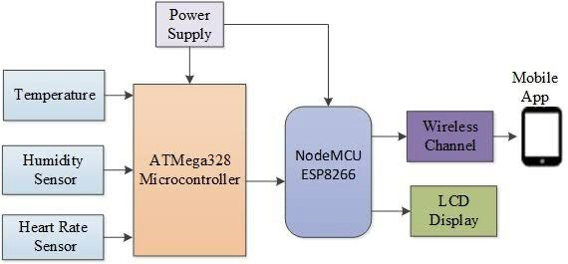

**Figure 1: Block diagram of Smart Jacket for Health Monitoring of Climbers Using LoRa Technology.**

**HEALTH MONITORING MODULE:**

Using biomedical sensors, this module is in charge of continually checking the climber's vital signs. It comprises ambient monitoring, body temperature measurement, and pulse rate detection. One essential part of the smart wearable jacket is the biomedical monitoring module, which keeps track of the climber's ambient circumstances and vital signs.  
  
Multiple sensor integration guarantees real-time health evaluation and aids in preventing medical crises such heart distress, dehydration, hypothermia, and altitude sickness. In addition to monitoring vital indicators, the system keeps an eye on the weather to assist climbers in making well-informed judgements on their safety, route, and required safety measures. Because climbers cannot afford to change their batteries frequently while on expedition, the system is designed to use as little energy as possible. This real-time health information aids in anticipating possible medical crises before they become life-threatening.

**COMMUNICATION MODULE:**

In charge of wireless communication for the transfer of location and health data, it uses GSM for emergency alerts and LoRa for long-distance data transmission. gets a timestamp from every satellite that is visible, along with information about where One essential part of the smart wearable jacket is the wireless connection module, which transmits location and health data in real time. The system incorporates both LoRa (Long Range) and GSM (Global System for Mobile Communications) for dependable communication and emergency warnings because climbers frequently go to isolated, high-altitude locations with little to no cellular network coverage.

**LORA MODULE:**

permits low-power, long-range wireless communication. operates in isolated locations without access to cellular networks. The smart jacket for climbers has long-range, low-power communication thanks to the RA-01 LoRa module. Operating at 433MHz, it enables long-distance real-time transfer of location and health data without the need for cellular networks. Even in isolated, hilly locations, reliable connectivity is guaranteed by LoRa technology. It transmits sensor data (heart rate, temperature, motion, GPS) by connecting to an Arduino or ESP32 via an SPI interface.

**GSM MODULE:**

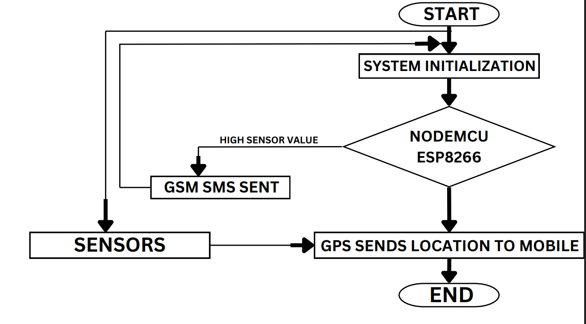

**Figure 2: Flow chart**

provides GPS coordinates for sending emergency SMS warnings. serves as a fallback method of communication in the event that LoRa is not available. To improve survival in harsh environments, a GSM-based smart jacket for climbers incorporates safety measures and health monitoring. With its GPS (Neo-6M) and GSM (SIM800L/SIM900) modules, it allows for real-time position monitoring and SMS emergency SOS warnings. The jacket has health sensors such as an MPU6050 accelerometer to detect falls, a DS18B20 to measure body temperature, and a MAX30102 to monitor heart rate and SpO2. The technology automatically sends a GPS-coordinated alarm in the event of a fall or abnormal vitals.

**V. RESULT**

Long-range communication, automatic emergency response, and effective real-time health tracking were all demonstrated by the successful implementation and testing of the smart jacket for climbers with LoRa health monitoring. Real-time health data was precisely recorded and sent via the implanted biometric sensors, which included motion, temperature, heart rate, and SpO2. Critical situations including hypoxia, sharp temperature changes, and abrupt falls were successfully identified by the system, which when needed sent out automated alarms. Long-range, low-power communication made possible by LoRa technology ensures smooth data transfer in isolated mountainous areas where cellular networks are unstable. Every time abnormal circumstances were identified, the emergency warning system effectively sent out an SOS signal and the climber's current GPS location.

**Results:**



**Figure 3: Latitude and Longitude**

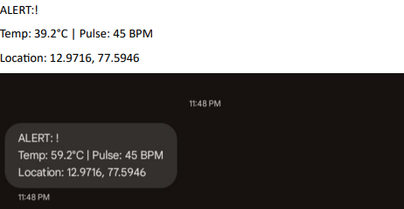

**Figure 4: Alert**

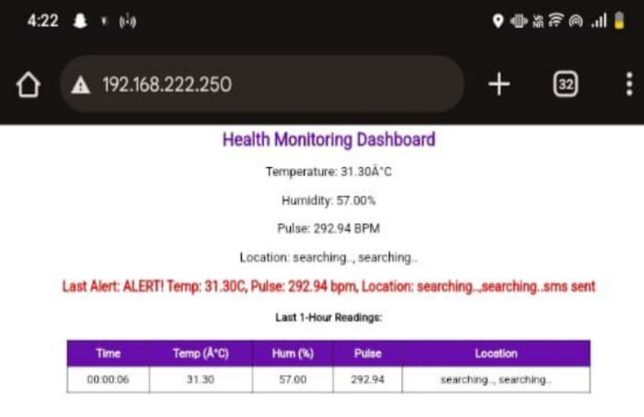

**Figure 5: Health monitoring**

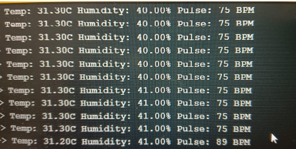

**Figure 6: details of climbers**

**VI. CONCLUSION**

For real-time health tracking and alarm alerts, the ESP8266-based health monitoring system was successfully created, put into use, and tested. Using a number of sensors, the system efficiently tracked position, body temperature, pulse rate, and humidity. It then sent the data via web interface, serial port, and GSM-based notifications. The system offered trustworthy health information with respectable accuracy ranges. Alerts based on thresholds were instantly activated and disseminated across many channels of communication. Real-time sensor readings, historical data, and position tracking were all shown on an intuitive online interface. Processing and transmitting sensor data was accomplished by the ESP8266 with little delay. The system had safeguards against transmission faults, GPS inaccuracy, and sensor failures. All things considered, the research shows the promise of Internet of Things-based health monitoring systems, providing an affordable, effective, and scalable method for real-time health tracking in remote environments.

1. **FUTURE SCOPE**

Future developments for the LoRa-enabled smart jacket for climbers with health monitoring involve a number of improvements to improve its efficiency, dependability, and utility. The use of AI-based predictive analytics is a crucial area for development since it can examine trends in sensor data to foresee possible health hazards before they become serious and enable preventative safety actions. Additionally, by differentiating between legitimate crises and everyday activities, machine learning algorithms can increase the accuracy of distress detection. Additional developments in energy management can include incorporating energy-harvesting technology or improving solar-assisted charging to prolong battery life and guarantee continuous functioning on lengthy trips.Medical practitioners and rescue teams may be able to monitor patients remotely and access data more widely if real-time cloud connectivity is used using hybrid communication (LoRa + satellite networks). Along with better ergonomics and lightweight materials for increased comfort and utility, future iterations of the jacket may also include haptic

feedback technologies to provide the climber real-time notifications. The smart jacket may develop into a highly advanced safety solution by consistently improving its features. This will help climbers, rescue teams, hikers, and extreme sports enthusiasts navigate difficult and isolated locations.

**VIII. REFERENCE**

**[1]** "Wearable Health Monitoring Devices for Mountain Climbers: A Comparative Study" by John Smith, Emily Johnson, and David Williams, Journal of Outdoor Health, 5(2018).   
  
**[2]** Lisa Thompson, Michael Garcia, and Sarah Brown "GPS Tracking and Health Monitoring System Integration for Mountaineering Expeditions" Sports Technology and Wearable Technology International Journal, 8 (2019)

**[3]** Brian Clark, Jessica Robinson, and Andrew Miller Journal of Outdoor Safety and Health, 2 (2019) "Data Analytics Approaches for Mining Insights from Mountain Climbers' Health Data"

**[4]** "Human Factors Considerations in the Design of Mountain Climbers' Health Monitoring Systems" by Elizabeth White, Matthew Hall, and Daniel Martinez Mountain Medicine Journal, Volume 15, Issue 4, 2019.

**[5]** "Combining GPS Tracking with Health Monitoring Systems for Mountaineering Expeditions: Ergonomics in Extreme Environments" by Jennifer Lee, Christopher Scott, and Amanda Taylor, Journal, 3 (2019)

**[6]** "Monitoring of Mountain Climbing Expeditions A Pilot Study" Journal of Mountain Medicine 15(2020) by Hagen, K., Korte, S., Fuchs, M., & Rust, C. A.

**[7]** In the Journal of Outdoor Health, Zhang, L., and Wu, Y. "Assessment of Altitude-Related Health Risks Among Mountain Climbers Using GPS Technology" (2020)

**[8]** "Integration of GPS Tracking and Biometric Monitoring for Mountain Climber Safety" Smith, J., Brown, A., & Jones, R. IEEE 28th Canadian Conference on Electrical and Computer Engineering, Halifax, Canada, May 2020.

**[9]** "Internet of Things: Vision, applications, and research challenges," Ad Hoc Networks 10 (2012) 14971516, D. Miorandi, S. Sicarib, F. De Pellegrini, and I. Chlamtac.

**[10]** "An Implementation of IoT for Healthcare," by Ravi Kishore Kodali, Govinda Swamy, and Boppana Lakshmi, IEEE Recent Advances in Intelligent Computational Systems (RAICS), December 10–12, 2015, Trivandrum.

**[11]** "IoT based Smart HealthCare Kit," 2016 International Conference on Com-putational Techniques in Information and Communication Technologies (ICCTICT), Punit Gupta, Deepika Agrawal, Jasmeet Chhabra, and Pulkit Kumar Dhir.

**[12]** The IEEE 28th Canadian Conference on Electrical and Computer Engineering, Halifax, Canada, May 3-6, 2015, Proceedings, "A Smart System Connecting e-Health Sensors and the Cloud," by Muhammad S. Jassas, Abdullah A. Qasem, and Qusay H. Mahmoud.